Lyon Kee

2/8/2020

Assignment 3

**Part 4**

A)

|  |  |  |
| --- | --- | --- |
| Test case setting | User input | Expected result |
| DISPLAY  7) Seconds of animation per flight hour: | -1 | DISPLAY  7) Seconds of animation per flight hour: |
| DISPLAY  7) Seconds of animation per flight hour: | 0.5 | Play animation slower than if it is 1 second |

B)

All the 9 cases ran as expected with the output as programmed but it helped me in identifying that I need my wind speed to be lesser than the airspeed or else the plane will have a speed of 0m/s or lesser which means it will never reach the destination.

C)

A function is implemented to make sure less memory is stored because of repetitions within a code, if the function is more than 25 lines, that means a large part of the code is stored and most likely used once which is not effective in the purpose it serve. Keeping it within 25 lines also help to identify the guideline to find which section of the code is the most repetitive to section off into a function.

D)

It is useful for a function to return void when you do not need to use the function for any other operations like comparing values or assigning values and so forth, because you can cout in a function and do other operations that allow you to reassign values of multiple variable.

**Part 5**

A)

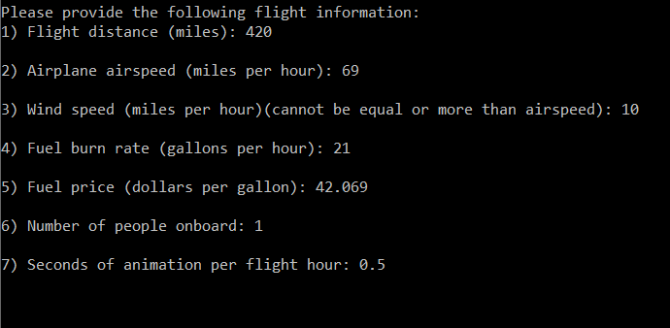

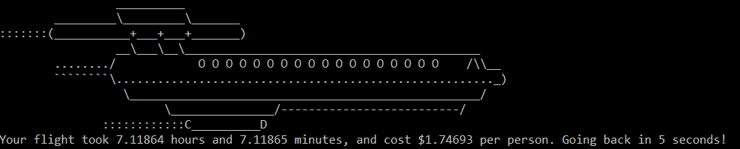 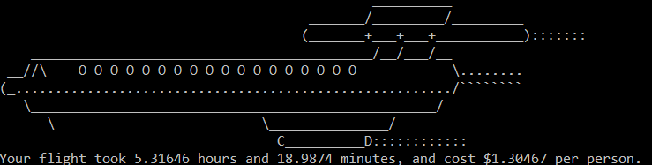

I gave it to a coursemate of mine and he said “Everything was simple and easy to use ,nothing unexpected happen and the air plain animation was cool”. I was happy that he liked the animation and if he wanted to learn I could talk to him about my implementation on that part. Everything behaved as inteded like when I was doing my own testing on my code.

B)

I could make it more realistic by having more guidelines on the mph of planes and the distances that planes travel typically as well as how much fuel would usually be burnt under the headwind and so on to make it more relatable in real life as there are many more factors at play.

C)

The inbound and outbound trips are not symmetrical because of the force acting on the plane by the windspeed. The outbound flight has a wind force that acts opposite to the direction of the flight whereas the inbound has a tail wind where it increases the speed of the plane. The formula for time suggests that time is distance over(airspeed – windspeed) for out bound and distance over (airspeed + windspeed) for inbound where we can por the windspeed as a portion of airspeed. Given A(airspeed) and (A*x)(windspeed) we know that they are not symmetrical because the speed difference will be (1 + x) / (1 – x) and the speed of the plane with the same conditions but no wind speed will fall under a ratio of 1:2 of decrease for inbound and increase for outbound. Resulting in the inversely proportional change in time and cost and cost is proportional to time.